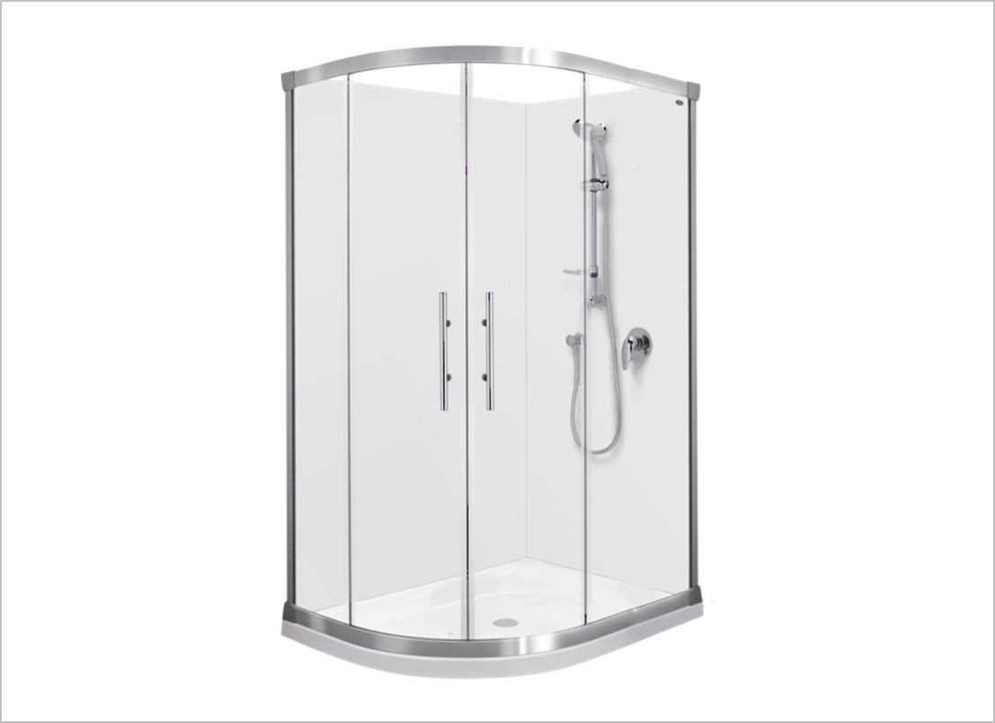

**Pay to Go Shower System**

SWEN3006 - Software Modeling

Group: 4

Kenneth Anglin ID#:180907           Email:180907@gist.edu.cn

Ottor Mills ID#:180917  Email180917@gist.edu.cn

David Thomas ID#:180912  Email180912@gist.edu.cn

Nicoy Smith ID#:180902  Email180902@gist.edu.cn

**Table of Contents**

Requirements Analysis 3

Static Model 11

Dynamic Interaction Model 12

State Diagram 16

Deployment Diagram 18

Component Diagrams 19

Textual Conclusion 21

Requirements Analysis

The Requirements Analysis with regards to software engineering is defined as the thorough examination of the outcomes for each use case and how those outcomes will affect the system on both micro and macro scales. In other words assessment is carried out to determine what use cases remain, modified or removed based on their feedback. Our project is an automated public shower system which uses QR codes for customer payments. The system is not timer based, instead the users shower is determined by a number of variables. The user pays a flat fee to use the shower and based on the user’s dimensions (height and weight) a certain amount of water and soap is allocated to the shower. This limit is usually a standard and is increased if the user has an extraordinary height or weight.

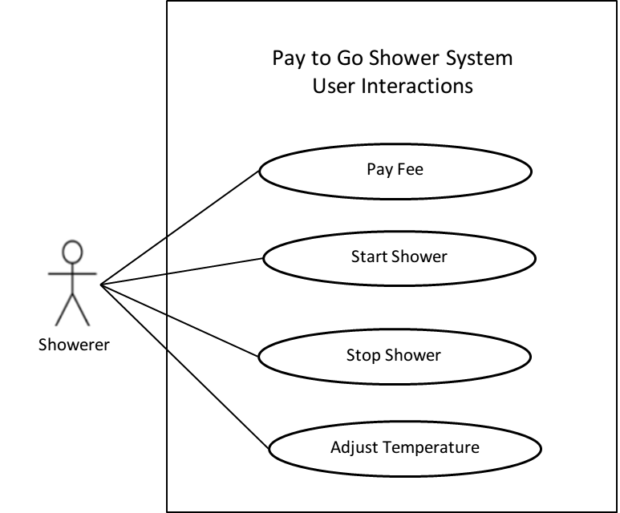

Description

The Diagram above illustrates all the performable actions by the user of the system

**Use case name:** Pay Fee

**Summary:** The shower transaction is paid for

**Actor:** Showerer

**Precondition:** User has enough money

**Main Flow:**

1. User uses smartphone to scan QR Code

2. User completes payment process

**Postcondition:**

None

**Use case name:** Start Shower

**Summary:** The User starts the Shower Process

**Actor:** Showerer

**Precondition:** User has paid their showering fee

**Main Flow:**

1.User steps into the shower.

2.The weight sensor is activated

3.The users weight is the determined

4.The users weight data is sent to the system

**Use case name:** Stop Shower

**Summary:** The User stops the Shower Process

**Actor:** Showerer

**Precondition:** The User has started the shower

**Main Flow:**

1. User stops the shower process

**Use case name:** Adjust Temperature

**Summary:** The user changes the temperature of the water.

**Actor:** Showerer

**Precondition:** Fee has been paid.

**Main Flow:**

1. User pays fee

2. User enters Shower

3. User sets desired temperature of water

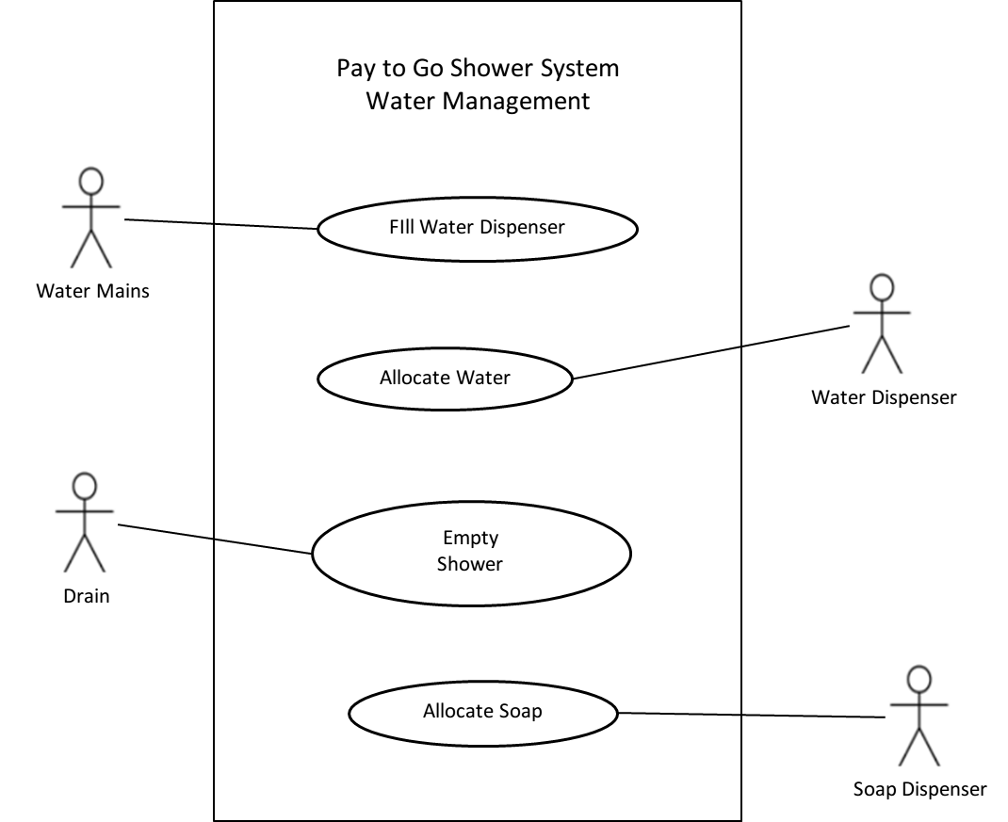

Description:

The Use Case Diagram above illustrates how the shower system would be supplied with soap, the soap dispenser requires a human to replenish its supply.

**Use case name:** Fill Water Dispenser

**Summary:** Water dispenser for shower is filled for single shower

**Actor:** Water Mains

**Precondition:** Public water is accessible

**Main Flow:**

1. User pays for shower

2. User enters shower

3. User’s BMI is calculated

4. Water dispenser is filled according to the user’s BMI

**Use case name:** Allocate Water

**Summary:** The shower system dispenses water to the user.

**Actor:** Water Dispenser

**Precondition:** The dispenser has been filled based on the user’s BMI

**Main Flow:**

1. User pays for shower

2. User enters shower

3. User’s BMI is Calculated

4. Water dispenser is filled

5. User can now start shower

**Use case name:** Empty Shower

**Summary:** The Water is drained out of the Shower

**Actor:** Drain

**Precondition:** The user is currently showering

**Main Flow:**

1. User starts shower

2. Drain removes excess water

**Use case name:** Allocate Soap

**Summary:** The shower system dispenses water to the user.

**Actor:** Soap Dispenser

**Precondition:** Fee has been paid.

**Main Flow:**

1. User pays for shower

2. User enters shower

3. User’s BMI is calculated

4. Soap dispenser is filled according to the user’s BMI

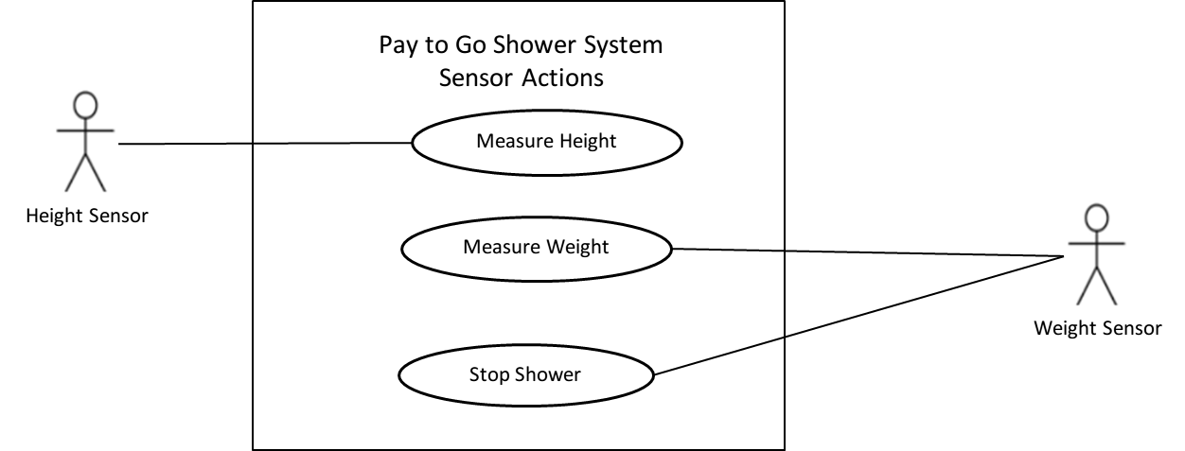

Description:

The Use Case Diagram above illustrates the actions performed by the two sensors of the shower system.

**Use case name:** Measure Height

**Summary:** Shower system is determines the user’s height

**Actor:** Height Sensor

**Precondition:** User has entered the shower

**Main Flow:**

1. User has paid shower fee

2. User steps into the shower.

3. The users height is measured

**Use case name:** Measure Weight

**Summary:** Shower system is determines the user’s weight

**Actor:** Weight Sensor

**Precondition:** User has entered the shower

**Main Flow:**

1.Shower is activated.

2. User steps into the shower.

3. The users weight is measured

**Use case name:** Stop Shower

**Summary:** Shower has been started

**Actor:** Shower, Water Dispenser

**Precondition:**

**Main Flow:**

1. User exits shower system, Weight sensor load is removed

2. Shower stopped

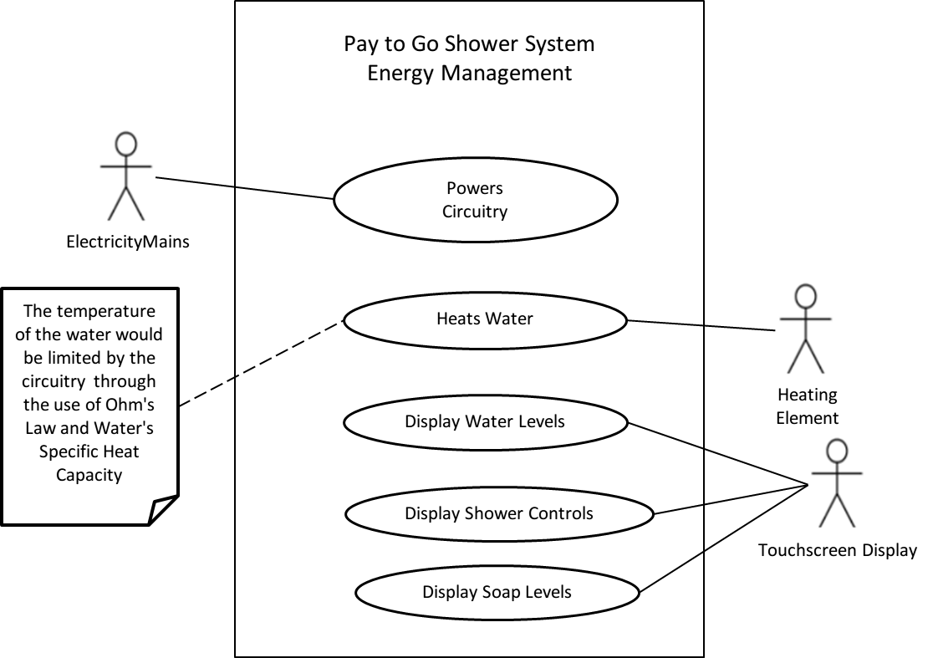

Description:

The Use Case Diagram above illustrates how electricity is distributed throughout the shower system.

**Use case name:** Powers Circuitry

**Summary:** Shower system is fuelled by the grid

**Actor:** Electricity Mains, Circuitry

**Precondition:** Shower system has access to the external power grid

**Main Flow:**

1. Shower system has been connected to the external power grid

**Use case name:** Heats Water

**Summary:** Shower system heats water.

**Actor:** Heating Element, Water

**Precondition:**

**Main Flow:**

1. Desired temperature is selected on the touchscreen display

2. Voltage across heating element modified.

3. The resistance of the heating element changes, subsequently causing its

temperature to change

**Use case name:** Display Water Levels

**Summary:** The shower system shows the current level of water to the user.

**Actor:** Touchscreen Display

**Precondition:** Showerer starts showering

**Main Flow:**

1. User Pays fee

2. User enters showering system

3. Current Water Level is shown to user until the user ends shower or until all

water has been dispensed.

**Use case name:** Display Soap Levels

**Summary:** The shower system shows the current level of soap to the user.

**Actor:** Touchscreen Display

**Precondition:** Showerer starts showering

**Main Flow:**

1. User Pays fee

2. User enters showering system

3. Current Water Level is shown to user until the user ends shower or until all

water has been dispensed.

**Use case name:** Display Shower Controls

**Summary:** The shower system shows the shower toggles to the user

**Actor:** Touchscreen Display

**Precondition:** Showerer enters shower

**Main Flow:**

1. User Pay fee

2. User enters showering system

3. The various shower controls are displayed to the user until user ends shower.

Static Model

Static Modeling is defined as a structural representation of a system that does not change over time. In other words a static model is the blueprint of the system. Although the Transaction class can be broken down into a Client class this is not necessary as the client has very little influence over the system. In other words it can be said that they are outside of the actual system which is the Pay to Go Shower system.

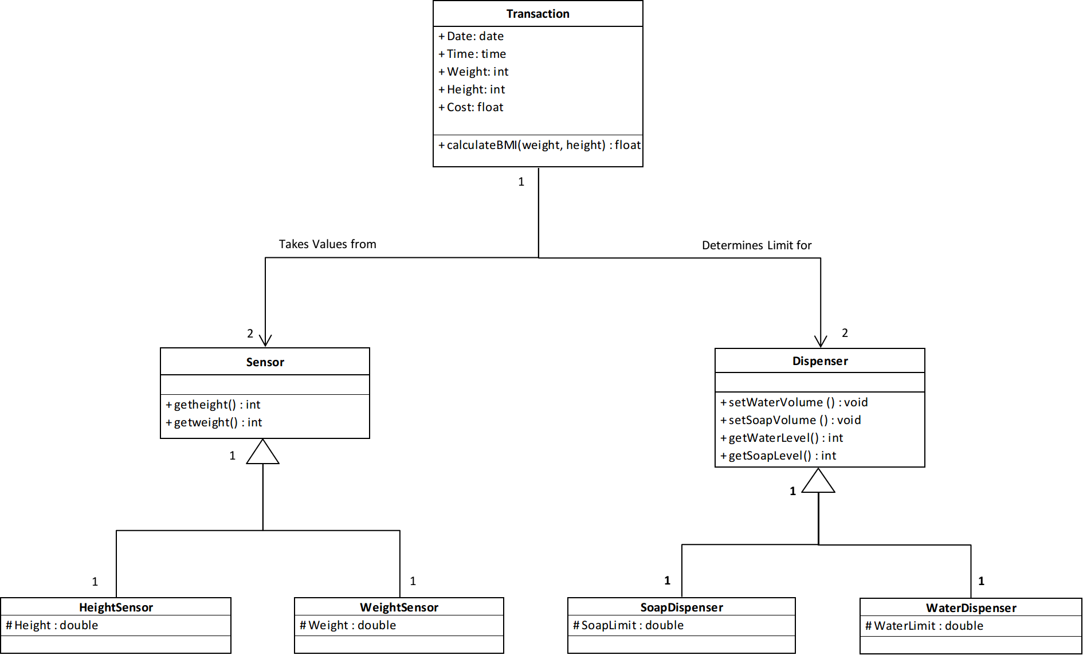

The class diagram above shows an overview of the system. A transaction consists of a flat fee however the allocated soap and water to a user determined by the values returned by the height and weight sensors. By default an optimal amount for the average person is allocated to the dispensers upon payment as this prevents unnecessary wastage, however if the client’s weight is too high or body mass index (BMI) calculated from the values returned by the height and weight sensors is above normal levels (overweight or obese) then more soap and water will be allocated to the dispensers to cover the larger surface area of the client. What is not used by the current client remains in the dispenser for the next client which promotes the reservation of resources.

Dynamic Interaction Model

Dynamic Interaction modeling is the representation of a system based on the communication within or between objects, states or actors.

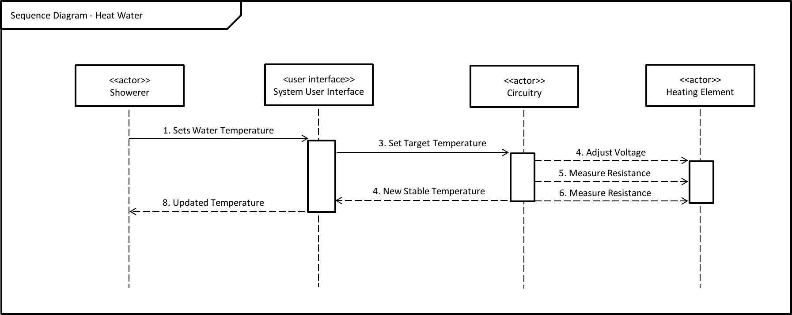

The Sequence Diagram above shows the sequence of events necessary to set the water to a desired temperature. Upon selecting a desired temperature on the touchscreen display, the circuit will adjust the voltage across the heating element in order to adjust its resistance which will subsequently adjust its temperature. As a guard condition present the circuitry limits the potential difference across the heating element in such a way that the water temperature remains below 70**°**C to prevent any harm to the showerer.

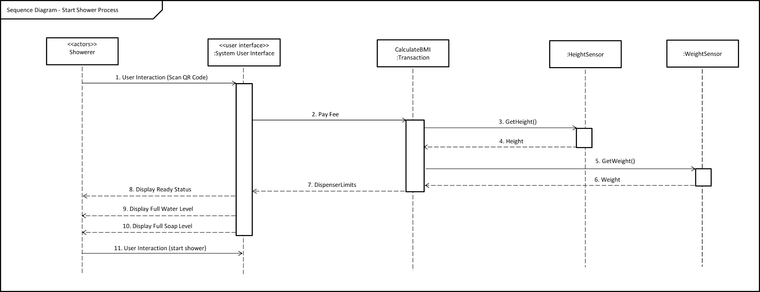

The Sequence Diagram above shows the start shower process. Once the user has scanned the QR Code and paid the flat fee, the API associated with the QR Code will return a true Boolean value to the control unit of the shower system which will trigger the Shower Ready event where the dispensers are filled based on the user’s dimensions. The user can then start the shower process when ready.

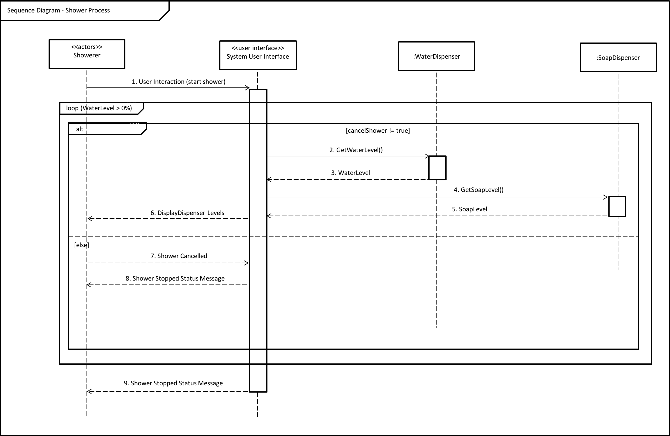

The Sequence Diagram above shows the processes involved in the actual shower. The shower process will continue as long as the water dispenser contains water and if the user has not stopped the process. However the user may turn on and off the water during the process.

The sequence diagram above shows the sequence of events involved in the payment process. Using the AliPay API the Pay to Go Shower System is able to process payment without many physical components. Once the payment as successfully been verified the shower will await the user’s initiation.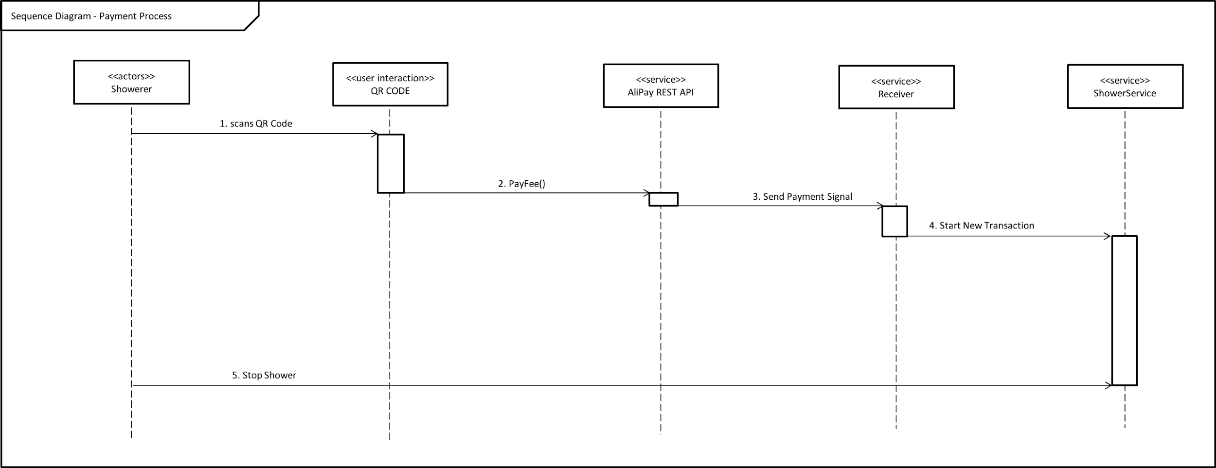

State Diagram

Shower States

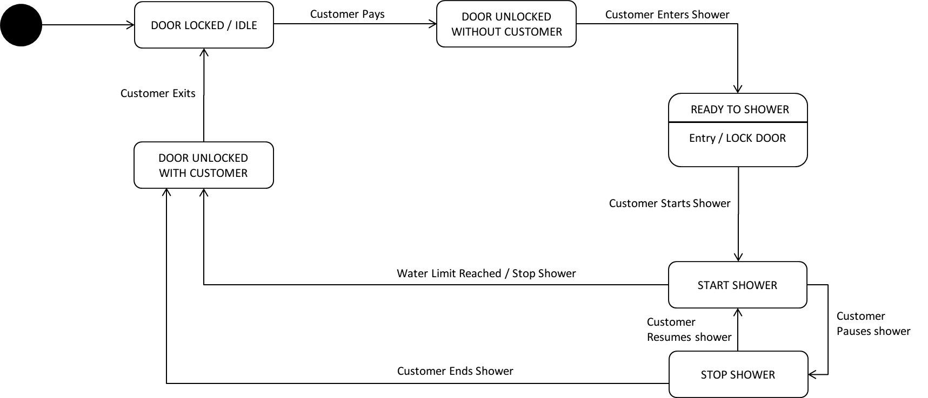

The State Chart Diagram above indicates the states of the entire Pay to Go Shower system. As shown during any stage of the shower the user is allowed to cancel the shower.

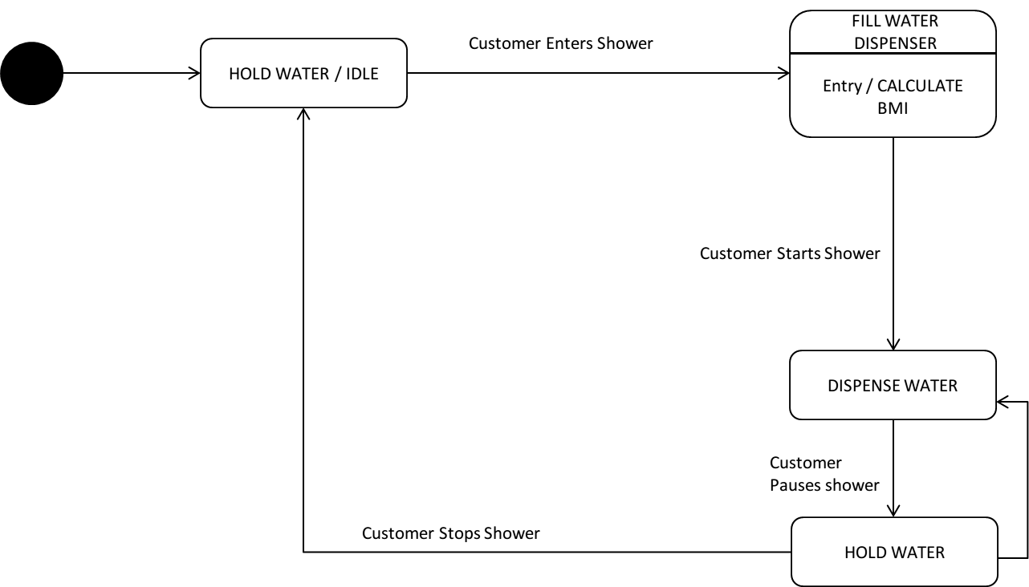

The State Chart Diagram above indicates the states of the water dispenser shower for the Pay to Go Shower system.

Deployment Diagram

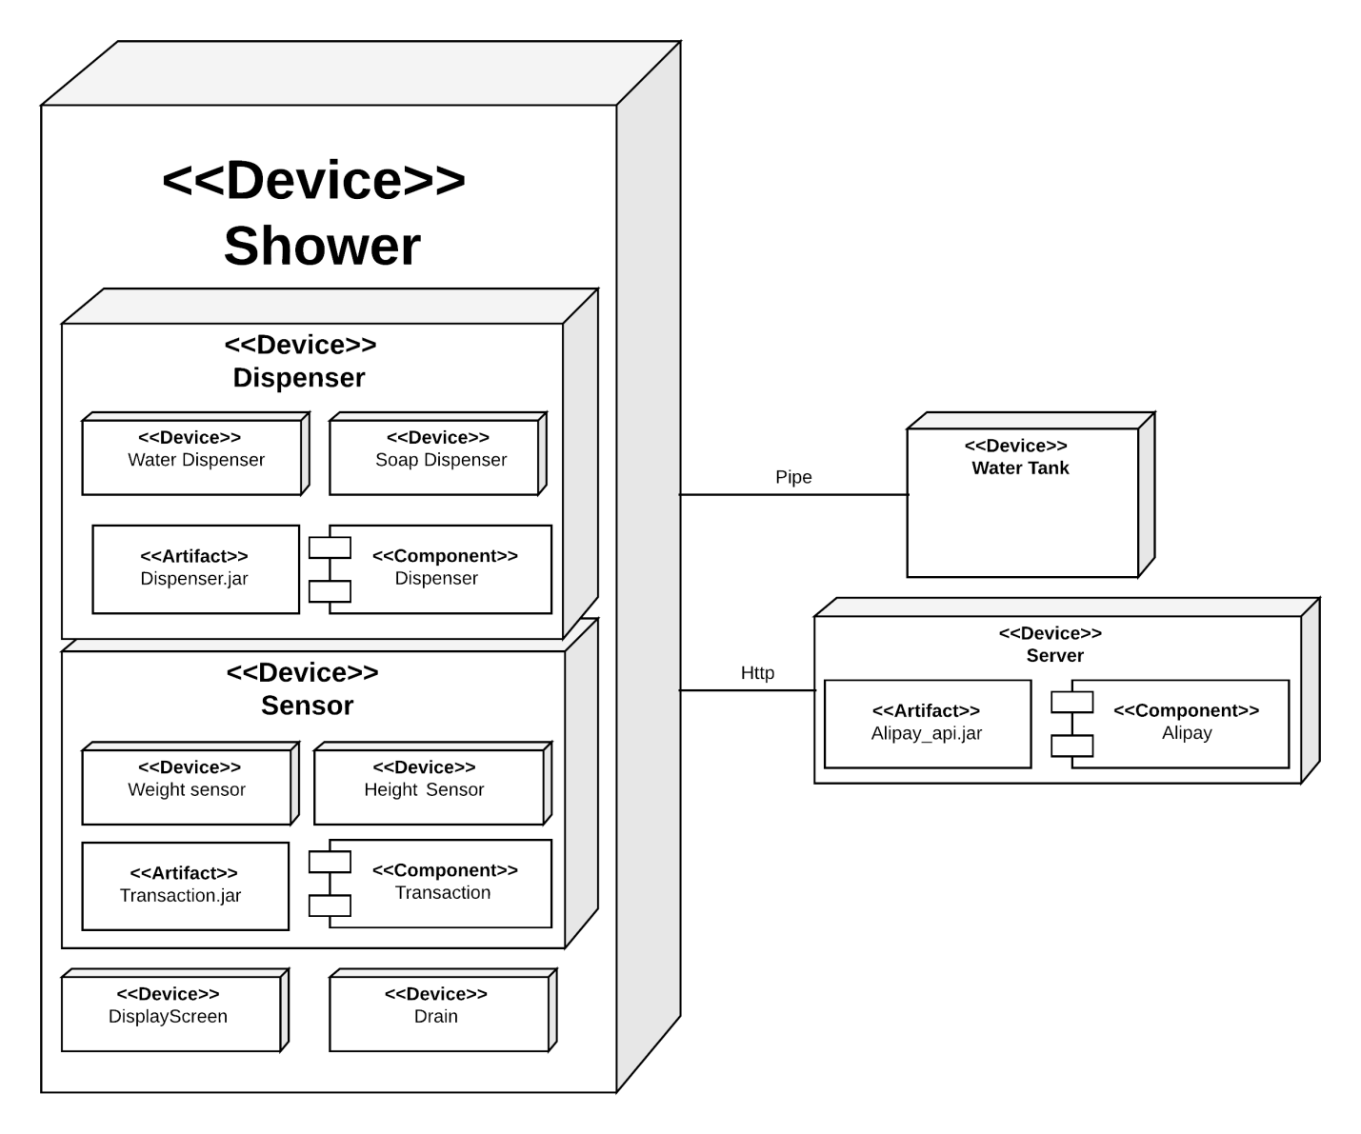

The Deployment Diagram above shows the shower system, its components and the external devices such as the water tank and the Server for processing the transaction received from the AliPay. The shower is comprised of several devices such as Water Dispensers, Soap Dispensers, Height and weight sensors, a display screen and a drain. The Shower is then connected to a water tank which is responsible for filling the water dispenser with water.

Component Diagrams

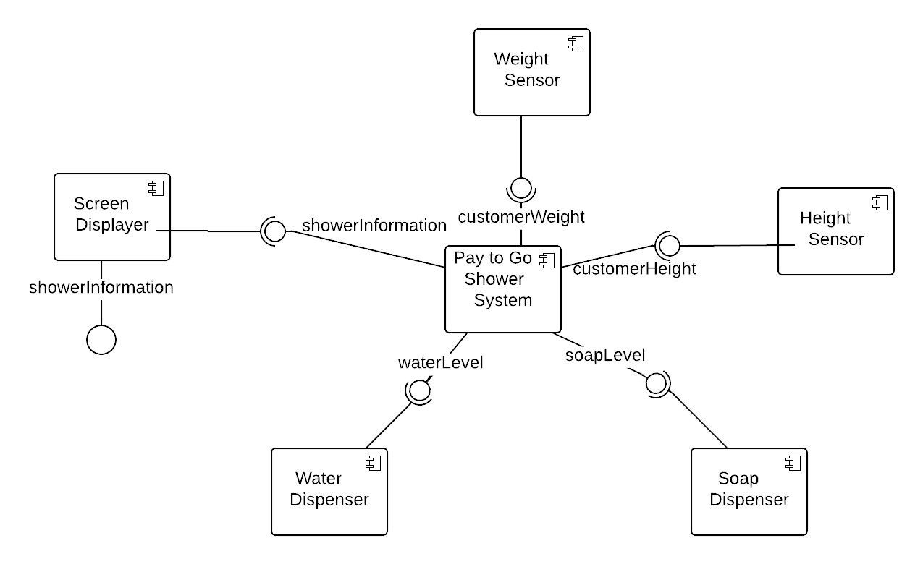

The component diagram above shows the components involved in the showering process of the system

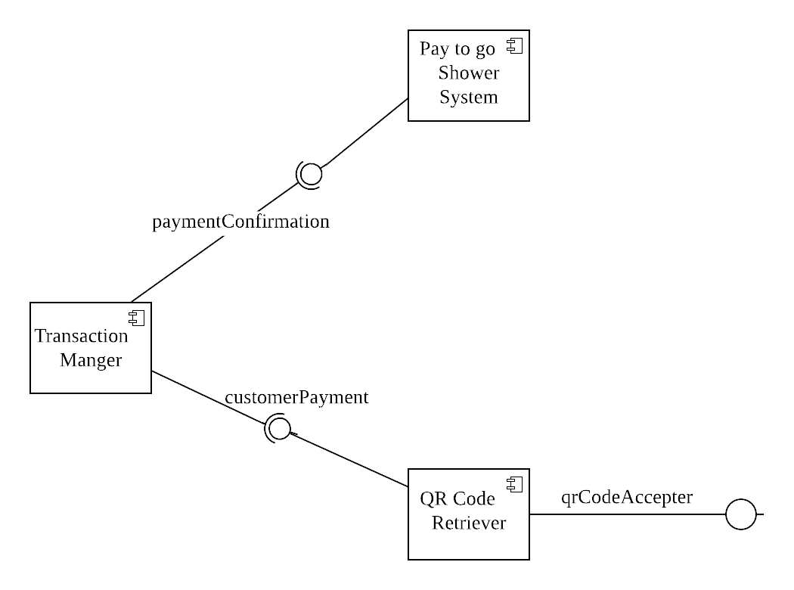

The component diagrams above shows all the components that is included in the payment process of the system.

Textual Conclusion

Sometimes individuals do not have immediate access to showers in public. The Pay To Go Shower System enables users to freshen up regardless of their location. Users simply scan the QR Code and pay for the service. The AliPay API will then send a confirmation signal to the shower system which will cause it to start a new transaction. This being said this is what makes the system unique as another system is currently not well known.